Alarm: ID 27: Error UDC Presence
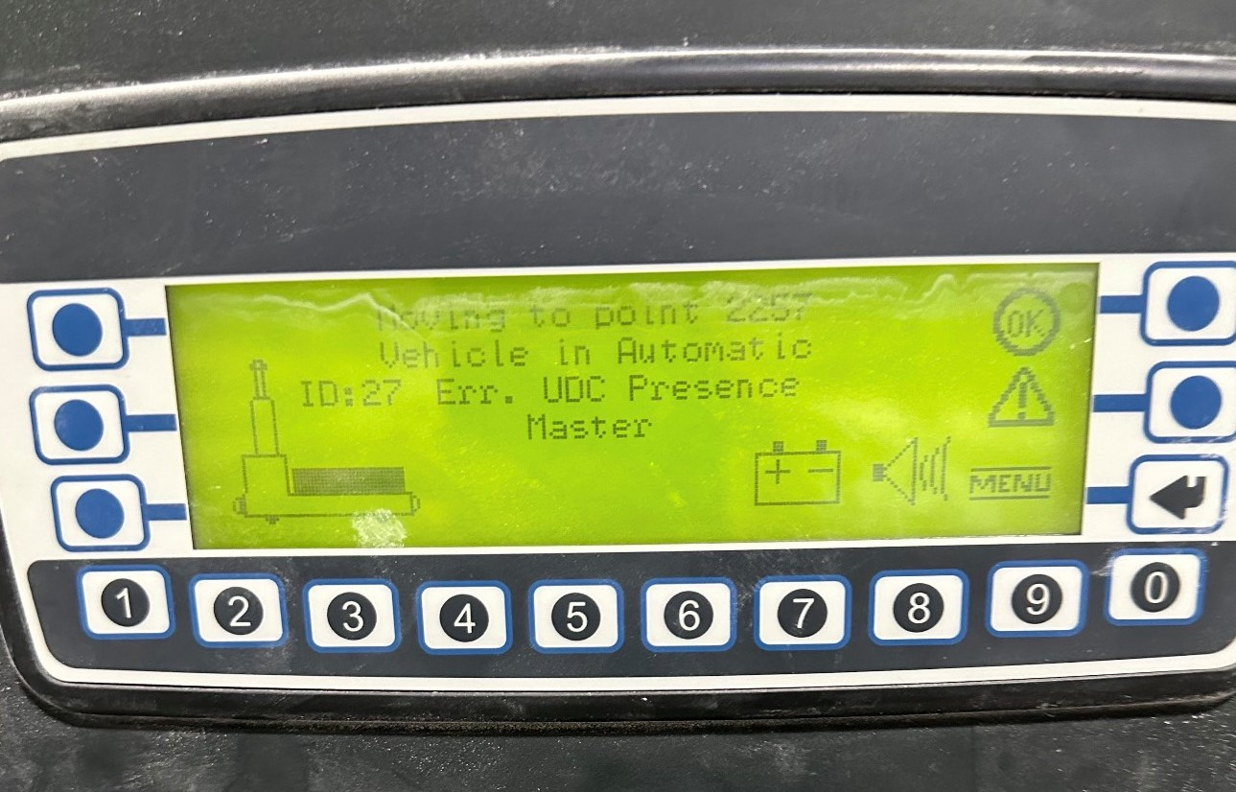
How To Fix:
This alarm occurs when the platform is not properly positioned on the AGV’s back table.
To resolve the issue:
- Ensure the platform is correctly placed on the AGV’s back table.
- If no platform is present, cancel the mission.
- Hold 2 on the AGV keypad to unload the AGV.

